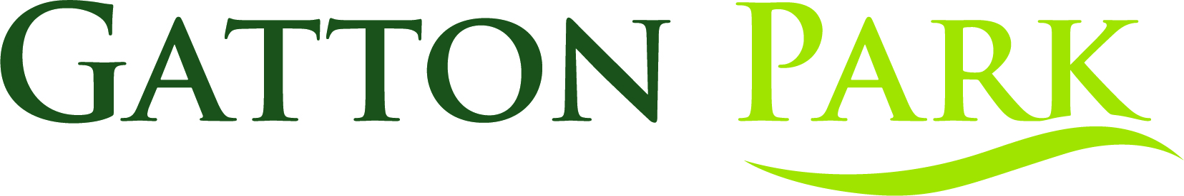
Birthday party booking form

- Call 01737 649066 to book your birthday party
- Then complete this form and email it to education@gatton-park.org.uk

Name
Address
Telephone
Email
Name of child
Age on birthday
Date of party
Time of party
Party theme
Max. number of children

Preferred payment method
Cost of birthday party: £175
Bacs payment  Account name: The Gatton Trust Ltd  Account number: 00013440  Sort code: 405240  CAF Bank Ltd | ☐
Debit card payment over the phone  Please call 01737 649068 | ☐
Cheque by post  Payable to The Gatton Trust  Gatton Park, Reigate, Surrey,  RH2 0TW | ☐

